Practical-6
Shubham Sonawane
Roll no-4401058
Div-A Batch D
#include <ESP8266WiFi.h>
#include <ESP8266WebServer.h>
const char* ssid="ENTC04";
const char* password="$inhgad@2122";
ESP8266WebServer server(80);
#define S1 D1
#define S2 D2
bool loggedIn=false;
void setup(){
Serial.begin(115200);
pinMode(S1,OUTPUT); pinMode(S2,OUTPUT);
digitalWrite(S1,HIGH); digitalWrite(S2,HIGH);
WiFi.begin(ssid,password);
Serial.print("Connecting to WiFi");
while(WiFi.status()!=WL_CONNECTED){delay(500);Serial.print(".");}
Serial.println("\nConnected!");
Serial.print("IP Address: ");
Serial.println(WiFi.localIP());
server.on("/",[](){
if(!loggedIn){
server.send(200,"text/html",
"<html><body style='text-align:center;background:#D6EAF8'>"
"<h2>Login</h2>"
"<form action='/login' method='POST'>"
"Username:<input name='u'><br><br>"
"Password:<input type='password' name='p'><br><br>"
"<input type='submit' value='Login'>"
"</form>"
"</body></html>");
}
else{
server.send(200,"text/html",
"<html><body style='text-align:center;background:#A9DFBF'>"
"<h2>Home Automation Control</h2>"
"<h3>Switch 1:</h3>"
"<a href='/on1'><button>ON</button></a> "
"<a href='/off1'><button>OFF</button></a><br><br>"
"<h3>Switch 2:</h3>"
"<a href='/on2'><button>ON</button></a> "
"<a href='/off2'><button>OFF</button></a><br><br>"
"<a href='/logout'><button>Logout</button></a>"
"</body></html>");
}
});
server.on("/login",[](){
if(server.arg("u")=="admin" && server.arg("p")=="admin123")
loggedIn=true;
server.sendHeader("Location","/");
server.send(303);
});
server.on("/logout",[](){
loggedIn=false;
server.sendHeader("Location","/");
server.send(303);
});
server.on("/on1",[](){digitalWrite(S1,LOW);server.sendHeader("Location","/");server.send(303);});
server.on("/off1",[](){digitalWrite(S1,HIGH);server.sendHeader("Location","/");server.send(303);});
server.on("/on2",[](){digitalWrite(S2,LOW);server.sendHeader("Location","/");server.send(303);});
server.on("/off2",[](){digitalWrite(S2,HIGH);server.sendHeader("Location","/");server.send(303);});
server.begin();
Serial.println("Web server started!");
}
void loop(){
server.handleClient();
}

OUTPUT:

Serial Monitor-
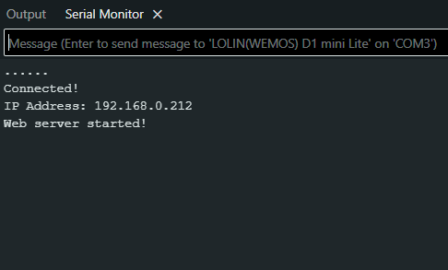
Webpages-
1.Login Page
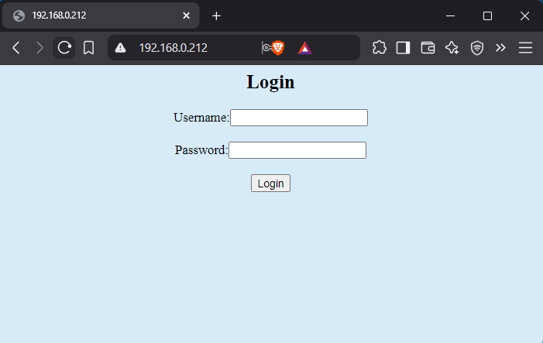
Control Page
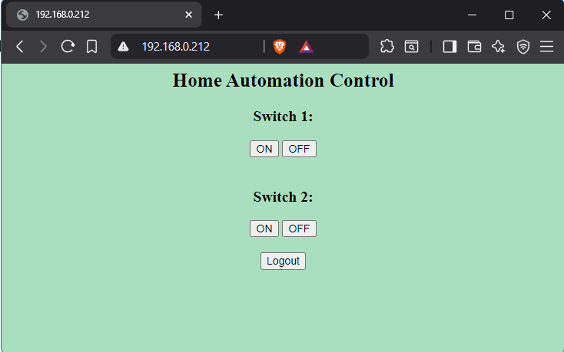
Hardware Output:
